**SRI SIDDHARTHA INSTITUTE OF TECHNOLOGY**

**MARALURU, TUMAKURU-572103**

**(A Constituent college of Sri Siddhartha Academy of Higher Education Deemed to be University)**

**DEPARTMENT OF INFORMATION SCIENCE AND ENGINEERING**



**Mini Project Report**

**On**

**“Child Health Care”**

Submitted in partial fulfillment of the requirement for the completion of V semester of

**BACHELOR OF ENGINEERING**

**Submitted by:**

KOUSHIK PAI :20IS044

LIKITH GOWDA M J :20IS050

**Under the guidance of:**

Mrs. Champakamala S

Assistant Professor

Dept. of ISE

**DEPARTMENT OF INFORMATION SCIENCE AND ENGINEERING**

**2022-23**

**SRI SIDDHARTHA INSTITUTE OF TECHNOLOGY**

**MARALURU, TUMAKURU-572103**

**(A Constituent college of Sri Siddhartha Academy of Higher Education, Deemed to be University)**

**DEPARTMENT OF INFORMATION SCIENCE AND ENGINEERING**



**CERTIFICATE**

Certified that mini project work entitled “**Child Health Care”,** is a bonafide work carried out by **KOUSHIK PAI (20IS044)** and **LIKITH GOWDA M J (20IS050)**, in partial fulfilment of the requirement for the completion of V semester in **Information Science and Engineering** of Siddhartha Academy of Higher Education- Tumakuru during the year 2022-23. It is certified that all corrections/suggestions indicated for Internal Assessment has been incorporated in the report. The report has been approved as it satisfies the academic requirements with respect to Mini Project work.

Signature of the guide Signature of the HOD

### Mrs. Champakamala S Dr. Karunakara K

Assistant Professor Professor & Head

Dept. of Information Science and Engg. Dept. of Information Science and Engg.

Sri Siddartha Institute of Technology Sri Siddartha Institute of Technology

Tumakuru-572105 Tumakuru-572105

**Name of the Examiners: Signature:**

**1.** _____________________________ __________________

**2.** _____________________________ __________________

**DECLARATION**

We, **KOUSHIK PAI (20IS044)** and **LIKITH GOWDA M J (20IS050)** of fifth semester, Department of Information Science and Engineering of Sri Siddhartha Institute of Technology, Tumakuru, hereby declare that this Mini project titled, **“Child Health Care”**, has been carried out by us under the supervision of  **Champakamala S**, Assistant Professor, Department of Information Science and Engineering , Sri Siddhartha Institute of Technology , Tumakuru in partial fulfilment of the requirement for the completion of V semester in Information Science and Engineering.

Date: 26/12/22

Place: Tumakuru

KOUSHIK PAI (20IS044)

LIKITH GOWDA M J (20IS050)

Abstract

The aim of this study was to investigate child health-care coordinators' experiences of being a facilitator for the implementation of a new national child health-care programme in the form of a web-based national guide. The study was based on eight remote, online focus groups, using Skype for Business. A qualitative content analysis was performed.

The analysis generated three categories: adapt to a local context, transition challenges and led by strong incentives. There were eight subcategories. In the latent analysis, the theme 'Being a facilitator: a complex role' was formed to express the child health-care coordinators' experiences.

Facilitating a national guideline or decision support in a local context is a complex task that requires an advocating and mediating role. For successful implementation, guidelines and decision support, such as a web-based guide and the new child health-care programme, must match professional consensus and needs and be seen as relevant by all. Participation in the development and a strong bottom-up approach was important, making the web-based guide and the programme relevant to whom it is intended to serve, and for successful implementation. The study contributes valuable knowledge when planning to implement a national web-based decision support and policy programme in a local health-care context.

Table of Contents Pg. No.

ABSTRACT iv

LIST OF FIGURES vi

LIST OF TABLES vi

**Chapter 1: Introduction**

* 1. Background 1
  2. Problem Statements 1

1.3 Aim and Objectives 2

**Chapter 2: Survey**

2.1 Literature Review 2

**Chapter 3: System Requirement and Specification**  3

**Chapter 4: Implementations**

4.1 Source code 5

4.2 System Module 11

**Chapter 5: Result and Discussions**

5.1 Sample Pictures 12

5.2 Tables 17

**Chapter 6: Conclusion & Future Scope**

6.1 Conclusion 19

6.2 Future Scope 19

**References**  19

**LIST OF FIGURES**

**Fig.No Description Pg. No.**

Figure 6.1.1 Home Page 12

Figure 6.1.2 About us page 12

Figure 6.1.3 List of features 13

Figure 6.1.4 Locate the hospitals 14

Figure 6.1.5 Experts Doctors Page 14

Figure 6.1.6 Ambulance Service Page 15

Figure 6.1.7 Contact Information 15

Figure 6.1.8 Locate hospital by entering the Pincodeeq 16

**LIST OF TABLES**

**Table. No Description Pg. No.**

Table 6.2.1 List of Doctors available 16

Table 6.2.2 List of ambulance available 16

**Chapter 1**

**Introduction**

In India, an estimated 26 million of children are born every year. As per Census 2011, the share of children (0-6 years) accounts 13% of the total population in the Country. Most of the people who visit [healthcare websites](https://colorwhistle.com/services/healthcare-medical-website-design/) are looking for information. So, these websites must be aesthetically pleasing, user-friendly, and easy to navigate.

Protecting and improving the health of children is of fundamental importance. Over the past several decades, we have seen dramatic progress in improving the health and reducing the mortality rate of young children. More than half of child deaths are due to conditions that could be easily prevented or treated given access to health care and improvements to their quality of life.

* 1. **Background:**

Your child deserves to be safe and well cared for at all times. One of your child care provider’s most important responsibilities is keeping your child safe from harm. One way your provider does this is by making sure that all adults with access to your child have had a comprehensive background check. Your child care provider should verify that this check shows that the adult does not have a history of child abuse or violence.

**1.2 Problem Statement:**

Children (aged 0 to 18 years) today face a host of new threats linked to climate change, pollution, harmful commercial marketing, unhealthy lifestyles and diets, injury and violence, conflict, migration and inequality.

The major causes of child mortality in India as per the SRS reports (2010-13) are: Prematurity & low birth weight (29.8%), Pneumonia (17.1%), Diarrheal diseases (8.6%), Other non-communicable diseases (8.3%), Birth asphyxia & birth trauma (8.2%), Injuries (4.6%), Congenital anomalies (4.4%), Ill-defined or cause unknown (4.4%), Acute bacterial sepsis and severe infections (3.6%), Fever of unknown origin (2.5%), and all other remaining causes (8.4%).

* 1. **Aim and Objective:**

The goal of the Child Health-Care is to end preventable child deaths and promote the healthy growth and development of all children in the first decade of their life. Child Health care is defined as the medical services that are provided by the medical health professionals to the children having disease or infection.

The preservation of the child’s health is no doubt the duty of the parents. But in most of the cases the child and his family do not know certain essentials of health. We describe instability of health insurance coverage for children aged 2 to 17 years and relate insurance instability to access, utilization and satisfaction.

f an early learning programme through the intervention of planned play activities that

**Chapter 2**

**Survey**

**2.1 Literature survey:**

If any child is ill and the parents wants to visit a doctor for checkup of their children, the parents need to visit the child hospital and waits until the doctor is available. The patient also waits in a queue while getting appointment. If the doctor cancels the appointment for some emergency reasons, then the patient is not able to know about the cancelation of the appointment unless or until he or she visits the hospital. As the mobile communication technology is developing rapidly. Therefore, one can use the mobile’s applications to overcome such problems and inconvenience for the patients.

* + - * A literature survey is a guide that helps a researcher to find, identify and define a problem.
      * This is the survey of the various [reports](https://www.template.net/editable/reports), books, [journals](https://www.template.net/business/journals/), articles that are related to our project work, which helps in the justification of our work.
      * The survey of child care professionals, conducted on March 17, 2022 and closed at midnight April 15, 2022.
      * The voluntary, anonymous survey was conducted in English and French and was open to child care professionals currently or recently (since 2020) working in child care in Canada.
* Prior to its dissemination, the survey was reviewed and approved by the University of Ottawa Research Ethics Board.

Survey respondents were invited to share their views, observations and practices related to environmental health and ecological sustainability in child care settings, including topics such as reducing children’s exposures to toxic chemicals in cleaning products, toys and plastics; improving indoor air quality; reducing energy consumption; and increasing children’s access to natural play spaces. This report should be considered preliminary analysis.

**Chapter 3**

**System Requirement and Specification**

* **HTML:** The **Hyper Text Markup Language** or **HTML** is the standard [markup language](https://en.wikipedia.org/wiki/Markup_language) for documents designed to be displayed in a [web browser](https://en.wikipedia.org/wiki/Web_browser). It can be assisted by technologies such as [**Cascading Style Sheets**](https://en.wikipedia.org/wiki/Cascading_Style_Sheets)**(CSS)** and [scripting languages](https://en.wikipedia.org/wiki/Scripting_language) such as [**JavaScript**](https://en.wikipedia.org/wiki/JavaScript).
* **CSS:** **CSS** is a simple design language intended to simplify the process of making web pages presentable. **CSS** handles the look and feel part of a web page.
* **JavaScript:** **JavaScript** is a dynamic computer programming language. It is lightweight and most commonly used as a part of web pages, whose implementations allow client-side script to interact with the user and make dynamic pages.
* **Bootstraps: Bootstrap** is a free front-end framework for faster and easier web development. Bootstrap includes **HTML** and **CSS** based design templates for typography, forms, buttons, tables, navigation, modals, image carousels and many other, as well as optional **JavaScript** plugins.

**Chapter 4**

**Implementations**

**4.1 Source Code**

<!DOCTYPE html>

<html lang="en">

<head>

    <meta charset="UTF-8">

    <meta http-equiv="X-UA-Compatible" content="IE=edge">

    <meta name="viewport" content="width=device-width, initial-scale=1.0">

    <title>Child Health-Care</title>

    <link rel="stylesheet" href="./css/stylesheet.css">

    <link rel="icon" type="image/x-icon" href="C:\Users\koush\Downloads\favicon (1).ico">

    <style>

        h1 {text-align: center;}

    </style>

</head>

<body>

<br>

<h1><i>Child Health Care</i></h1>

    <hr>

    <section id="header">

        <div class="container">

            <div class="headertext">

                <h1>Keeping your child safe,wherever you are.</h1>

                <span class="square"></span>

                <p>We're here when you need us with the same safe,high-quality care we've always offered,even during the pandemic.

             Now, in many cases, you can get that care without even leaving home because we offer virtual visits across every one of our specialties.</p>

            <button class="common-btn"><a href="#about">Read More</a></button>

            <div class="line">

                <span class="line-1"></span><br>

                <span class="line-2"></span><br>

                <span class="line-3"></span>

            </div>

            </div>

        </div>

    </section>

    <nav id="sidenav">

        <ul>

            <li><a href="#header">HOME</a></li>

            <li><a href="#about">ABOUT</a></li>

            <li><a href="#features">FEATURES</a></li>

            <li><a href="#contact">CONTACT</a></li>

        </ul>

    </nav>

  <hr>

    <img src="images/menu.png"  id="menuBtn">

    <!-- about -->

    <section id="about">

        <div class="about-left-col">

            <img src="https://img.freepik.com/free-vector/cartoon-doctors-nurses_52683-59918.jpg?w=2000.png" alt="about">

        </div>

        <div class="about-right-col">

            <div class="about-text">

                <h1>About Us</h1><br>

                <span class="square"></span><br>

                <p>The proposed project is a smart child health care system that provides children or any user an easy way of booking a doctor’s appointment online.

            This is a web based application that overcomes the issue of managing and booking appointments according to user’s choice or demands.

            The task sometimes becomes very tedious for the compounder or doctor himself in manually allotting appointments for the users as per their availability.

            Hence this project offers an effective solution where users can view various booking slots available and select the preferred date and time...

            <button class="common-btn"><a href="#features">Next</a></button>

            </p>

            <br>

                  <div class="line">

                    <span class="line-1"></span><br>

                    <span class="line-2"></span><br>

                    <span class="line-3"></span>

                </div><br>

                <h2> While children are struggling to be unique, the world around them is trying to make them look like everybody else...</h2> <br>

                <h3>--Abdul Kalam--</h3> <br>

            </div>

        </div>

    </section>

    <hr>

    <!-- features -->

    <section id="features">

        <div class="features-row">

            <div class="features-col">

                <img src="https://cdn.icon-icons.com/icons2/2642/PNG/512/google_map_location_logo_icon_159350.png" alt="pic1">

                <h4>Find Hospitals</h4>

                <p>Finding the nearby hospitals in the area by area pincode.</p>

                <br>

                <br>

                <br><br>

            <button class="common-btn"><a href="#courses">Go</a></button>

        <br>

            </div>

            <div class="features-col">

                <img src="https://media.istockphoto.com/id/1139549801/vector/stethoscope-heart-icon.jpg?s=612x612&w=0&k=20&c=qEJ7fFxWkok8j7FYYj4NwAlHSgqsw-azZz7c3IQJ4KI=" alt="pic2">

                <h4>Expert doctors</h4>

                <p>You can book an doctor appointment,if you know respected doctors.</p>

            <div class="feature-btn">

            <button class="common-btn"><a href="#offer">Connect</a></button>

        </div>

            </div>

            <div class="features-col">

                <img src="https://cdn3d.iconscout.com/3d/premium/thumb/ambulance-5796450-4844847.png" alt="pic3">

                <h4>Fast Ambulances Service</h4>

                <p>There is a fast service of Ambulance throughout the city</p>

            <div class="feature-btn">

            <button class="common-btn"><a href="#course">More</a></button>

        </div>

            </div>

        </div>

    </section>

    <br>

<script>

function myfun(){

 var x=event.location;

 document.getElementById("demo").innerHTML="you clicked me";

}

</script>

  <!-- Find Hospital -->

    <section id="courses">

        <div class="container course-row">

            <div class="course-left-col">

            <div class="course-text">

                <h1>Locate hospital near you</h1>

                <span class="square"></span><br>

                <p>Some hospitals formed specially for serving medical causes of childrens.To get the list of the child care hospitals near you,you want to press on below buttuon.<br>

            </p>

            <form action="/action_page.php">

             <label for="fname">Click Below:</label><br>

                <button class="common-btn"><a href="web2.html">

            Find</a></button>

              <div class="line">

                    <span class="line-1"></span><br>

                    <span class="line-2"></span><br>

                    <span class="line-3"></span>

                </div><br>

            </div>

            </div>

            <div class="course-right-col">

                <img src="https://cdni.iconscout.com/illustration/premium/thumb/man-finding-near-by-hospital-3958599-3277768.png" alt="coursepic">

            </div>

        </div>

    </section>

    <!-- Expert Doctors -->

    <section id="offer">

        <div class="about-left-col">

            <img src="images/expert_dr.JPG" alt="about">

        </div>

        <div class="about-right-col">

            <div class="about-text">

                <h1>Expert Doctors</h1>

                <span class="square"></span><br>

                <p>You can book an appointment with the doctors. And also you can clarify the doughts by asking the experts.If you know some expert but you want to contact them you can get their contacts over here.</p>

            <button class="common-btn"><a href="web4.html">Call</a></button>

                <div class="line">

                    <span class="line-1"></span><br>

                    <span class="line-2"></span><br>

                    <span class="line-3"></span>

                </div>

           </div>

        </div>

    </section>

    <!-- Ambulance Service -->

    <section id="course">

        <div class="container course-row">

            <div class="course-left-col">

            <div class="course-text">

                <h1>Fast Ambulance Service</h1>

                <span class="square"></span><br>

                <p>The fastest Ambulance service at your finger tip.Get a quick Ambulance services at your desired destination.</p>

                <button class="common-btn"><a href="wed5.html">Go</a></button>

                <div class="line">

                    <span class="line-1"></span><br>

                    <span class="line-2"></span><br>

                    <span class="line-3"></span>

                </div><br>

            </div>

            </div>

            <div class="course-right-col">

                <img src="https://cdni.iconscout.com/illustration/premium/thumb/man-finding-near-by-hospital-3958599-3277768.png" alt="coursepic">

            </div>

        </div>

    </section>

    <!-- Contact -->

    <section id="contact">

        <div class="container contact-row">

            <div class="contact-left-col">

                <h1>Connect with us:</h1>

            <h2>Phone1:<a href="tel:+916363479360">6363479360</a>

                <br>Phone2:<a href="tel:+919731072103">9731072103</a></h2>

                    <h2>For any queries email us by a single click below<h2>

                <div class="btn-box">

                        <button class="common-btn"><a href="web3.html">

                    Click Here</a></button>

                    </div>

                </form>

                <div class="line">

                    <span class="line-1"></span><br>

                    <span class="line-2"></span><br>

                    <span class="line-3"></span>

                </div>

            </div>

            <div class="contact-right-col">

                <img src="https://img.freepik.com/premium-vector/illustration-vector-graphic-cartoon-character-contact-us_516790-909.jpg" alt="">

            </div>

        </div>

    </section>

    <!-- Footer -->

    <section id="footer">

        <hr>

        <div class="container footer-row">

            <div class="footer-left-col">

                <div class="footer-links">

                <div class="link-title">

                    <h4>Products</h4>

                    <small>Our Plan</small><br>

                    <small>Free Trial</small>

                </div>

                <div class="link-title">

                    <h4>About Us</h4>

                    <small>Request Demo</small><br>

                    <small>FAQs</small>

                </div>

                <div class="link-title">

                    <h4>Support</h4>

                    <small>Features</small><br>

                    <small>Contact Us</small>

                </div>

                <div class="link-title">

                    <h4>Explore</h4>

                    <small>Find a nonprofit</small><br>

                    <small>Coporate Solution</small>

                </div>

            </div>

            </div>

            <div class="footer-right-col">

                <div class="footer-info">

                    <div class="copyright-text">

                        <small>20is044@ssit.edu.in</small><br>

                        <small>20is050@ssit.edu.in</small><br>

                        <small>copyright &copy;2022</small>

                    </div>

                    <div class="copyright-logo">

                    </div>

                </div>

            </div>

        </div>

    </section>

    <!-- Social-icons -->

    <div class="social-icons">

        <img src="images/facebook.png" alt="facebook">

        <img src="images/instagram.png" alt="instagram">

        <img src="images/twitter.png" alt="twitter">

        <img src="images/linkedin.png" alt="linkedin">

    </div>

    <script>

        var menuBtn = document.getElementById("menuBtn");

        var sidenav = document.getElementById("sidenav");

        sidenav.style.right = "-250px";

        menuBtn.onclick = function(){

            if(sidenav.style.right == "-250px"){

                sidenav.style.right = "0";

            }

            else{

                sidenav.style.right = "-250px";

            }

        }

    </script>

</body>

</html>

**4.2 System Module**

* As soon as the program get executed with no errors, the web page is created in the specified folder. When we open the specified folder and click on web-page.
* When the page gets loaded, you can find Home Page or Introduction page of the web site with the Menu button on the right top most corner.
* In the Menu bar, you can find 4 tabs those are namely: 1. Home, 2. About us , 3. Features, 4. Contact. When user press on “Home” section where ever the user gone through the website he returns to the home page/Starting Pages of our website.
* In Home Page or Starting page, user can also find the introduction of the child health.
* When the user scroll down from the web page, he/she can see the “About us” page where they gets to know about why this project is used and what is the purpose of this project.
* As soon as the user reads the About us page, they can scroll down to get the features available in the Website. Which includes finding the hospital in the specified area, contact the Expert doctors available, contact the Ambulance driver available.
* The first feature is to locate a hospital near the area, as soon as the user click on the find button, he will redirect to a search page where the user must enter the pin code of the city, which generates a link, by clicking on that link he can redirect to the google map and gets the hospital list nearby in that area.
* The second feature is to contact an available expert doctor. When the user clicks on connect/call button they navigate to the webpage where the user can get a list of doctors along with their details available in that area and they can contact them.
* The last feature of the web page is Fast Ambulance Service. When the user click on the more/go button they navigate to the webpage where they get a list of Ambulance Driver name, driver contact number, and vehicle number.
* The User can contact us through our contact number specified and also, they can contact us through mail by “click here” button in Contact Tab.
* When the user press on “Click here” tab, they redirects to a webpage where the user want to enter his personal details like name and mail id and also what he want to ask . After entering the details user want to click on submit button which redirects to the email. Where he can send his mail to us.

**Chapter 5**

**Result and Discussions**

**5.1** **Sample Pictures**

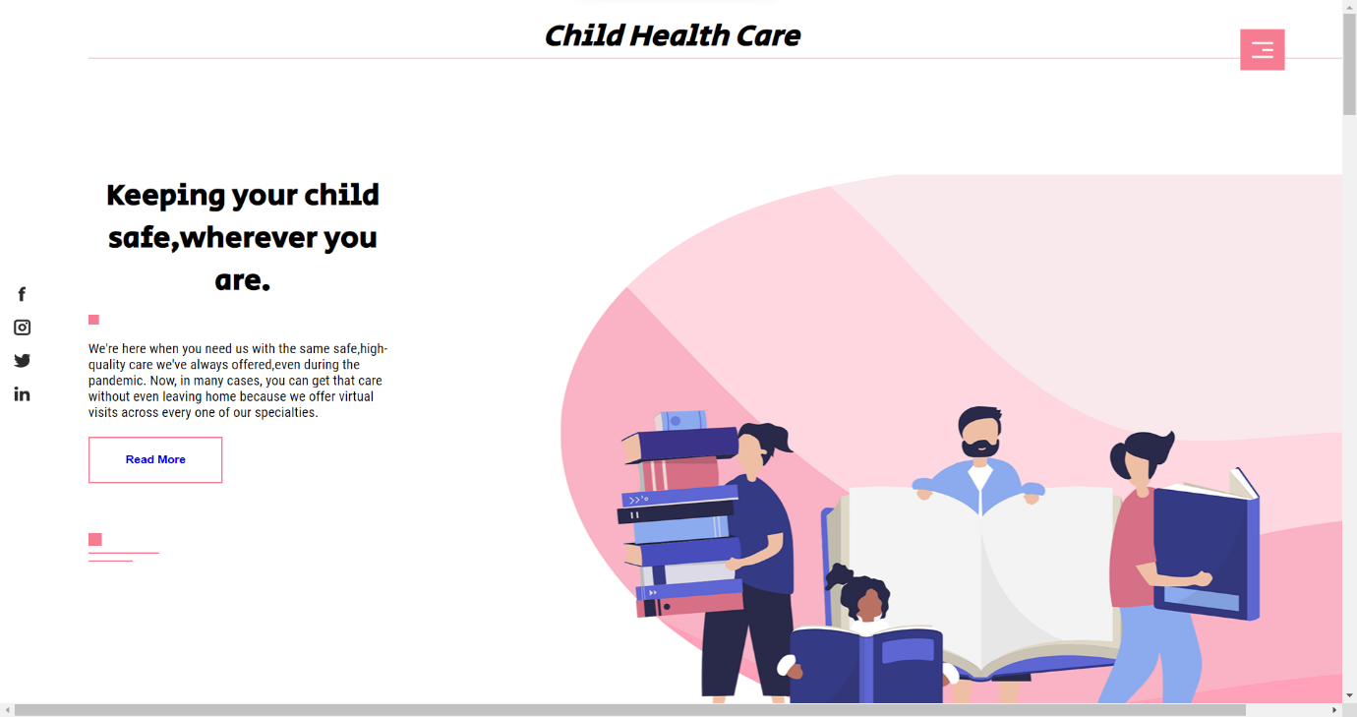

Figure 5.1.1 Home Page

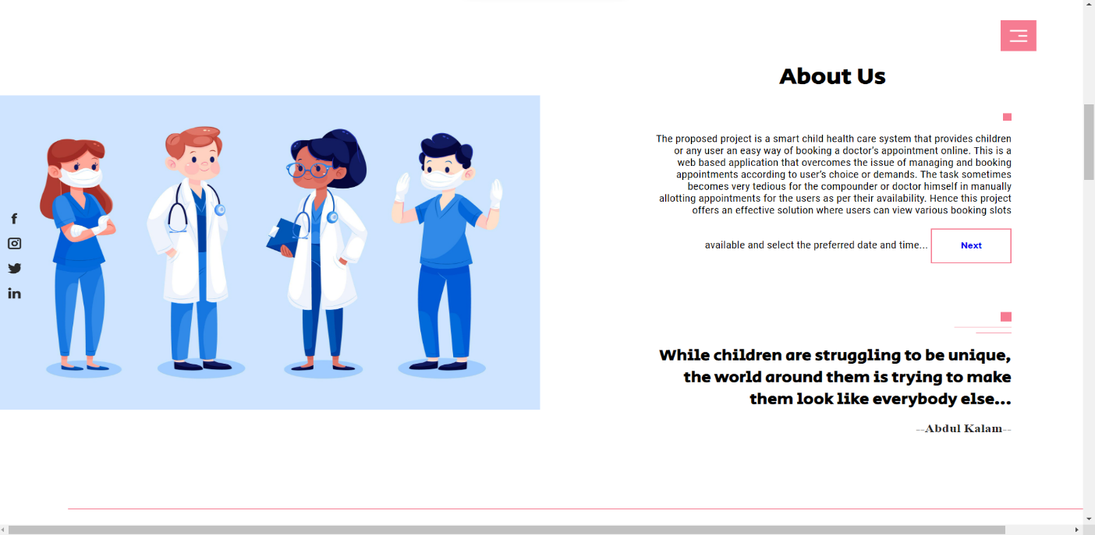

Figure 51.2 About us Page

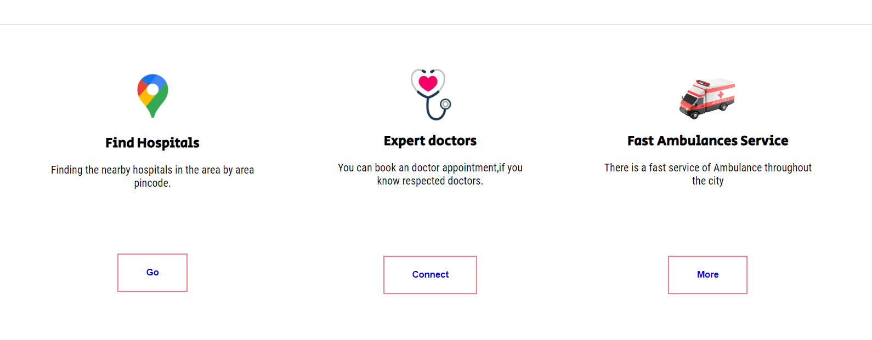

Figure 5.1.3 List of Features

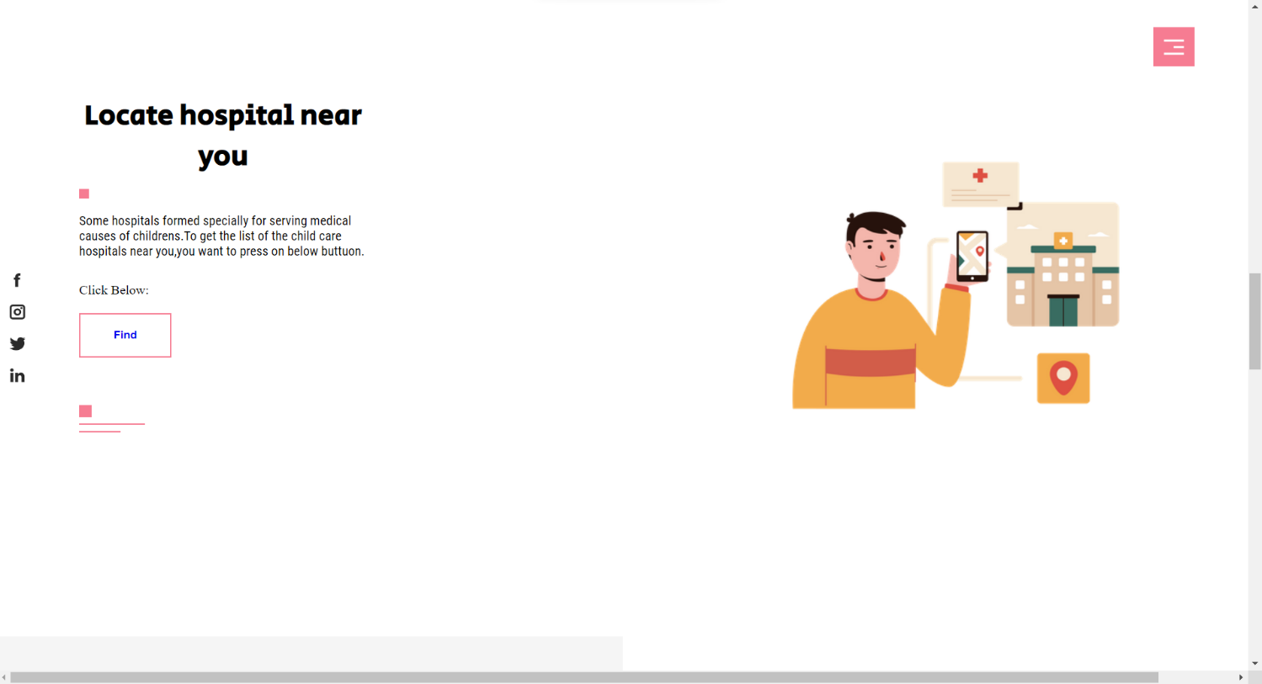

Figure 5.1.4 Locate the Hospitals

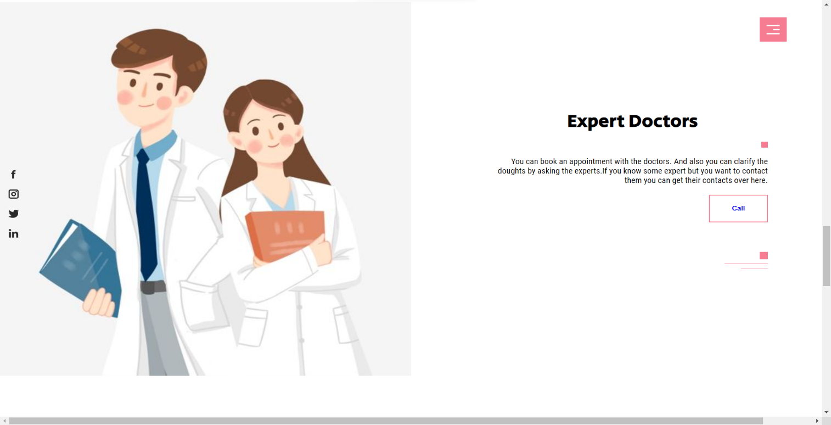

Figure 5.1.5 Expert doctors

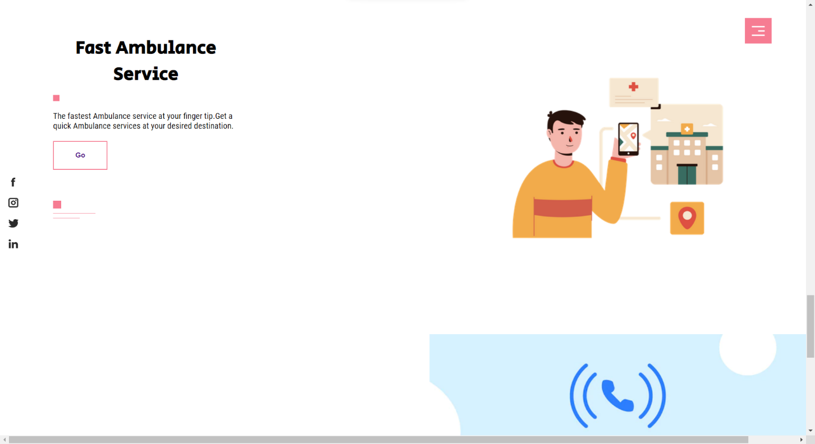

Figure 5.1.6 Fast Ambulance Services

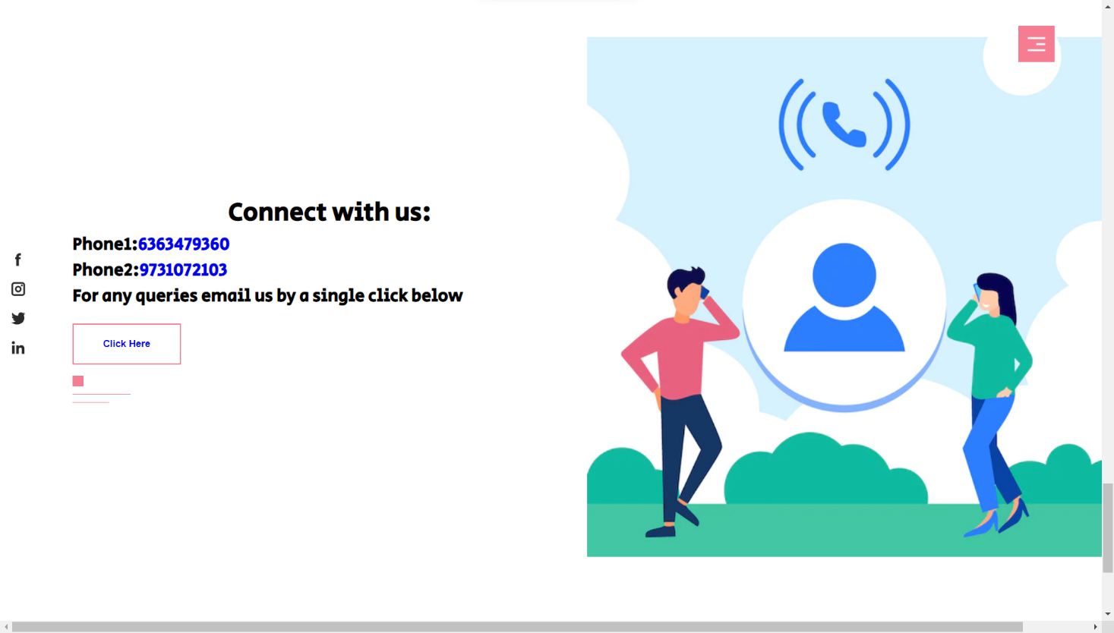

Figure 5.1.7 Contact Information

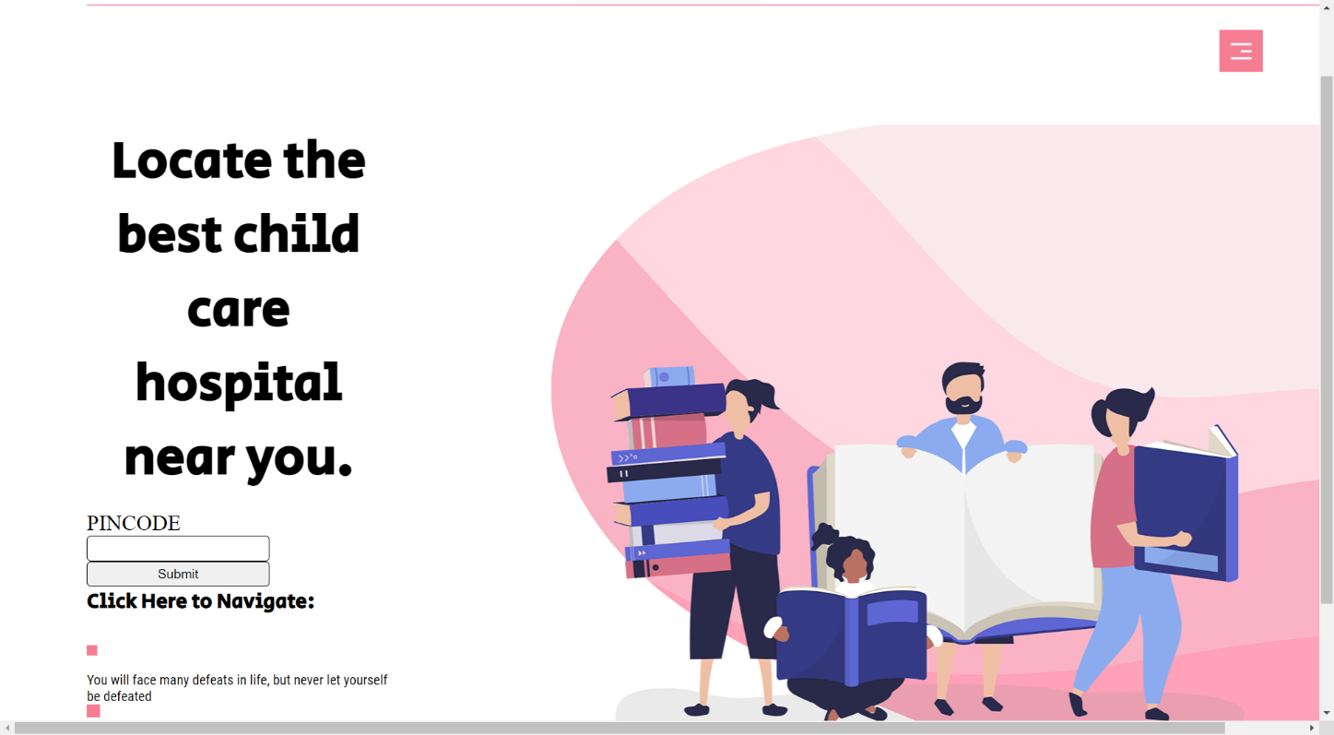

Figure 5.1.8 Locate hospital by entering the Pin code

**5.2 Sample Tables**

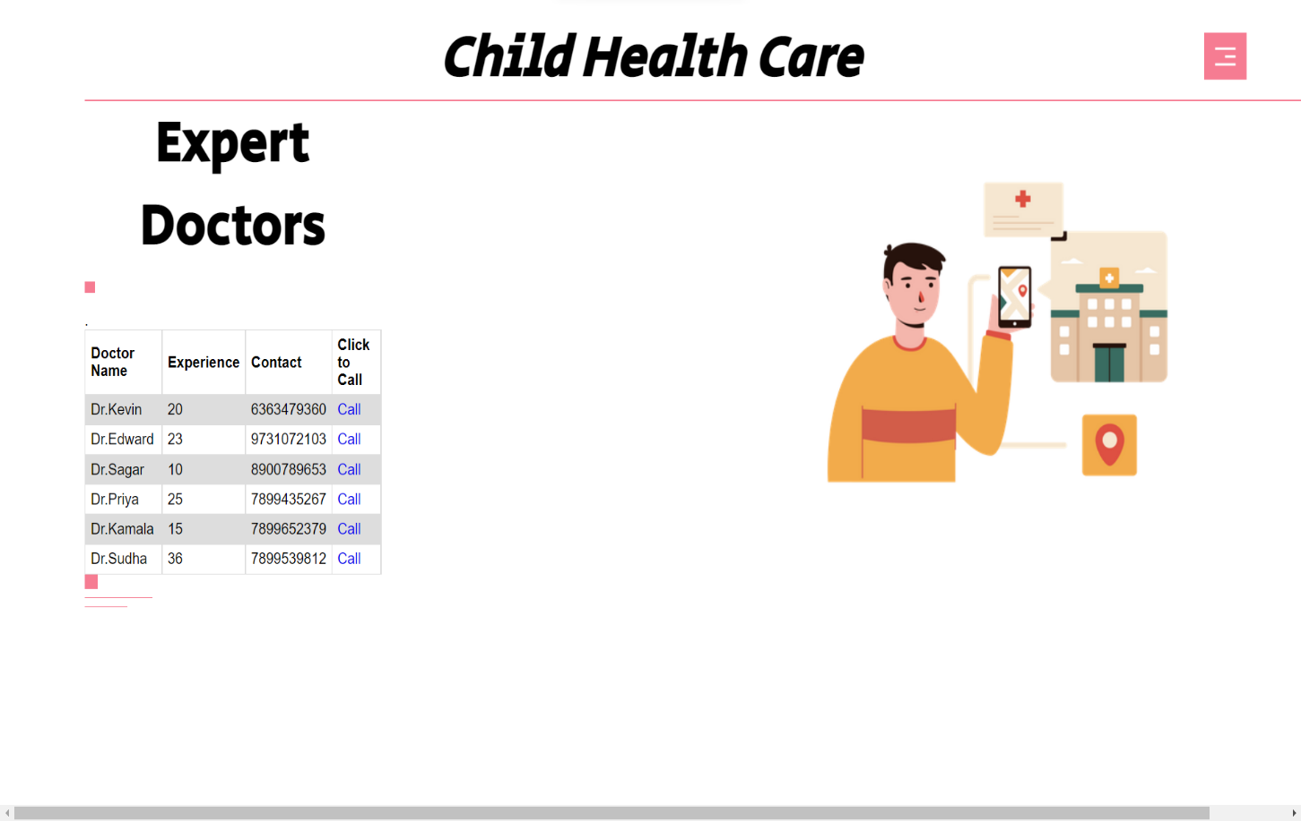

Table 5.2.1 List of Doctors available

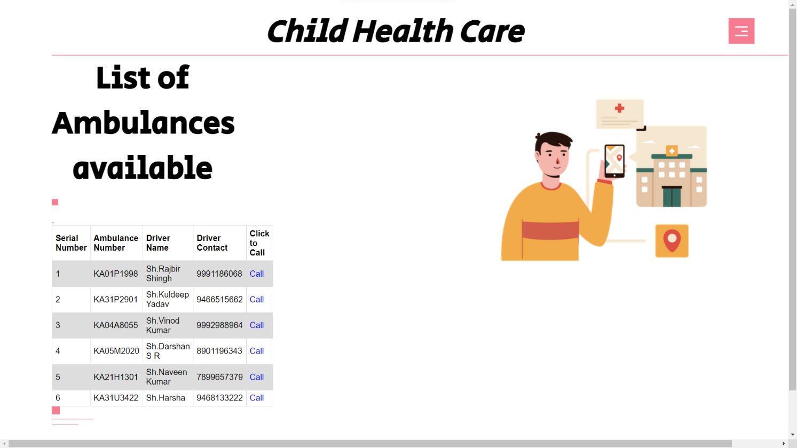

Table 5.2.2List of ambulance available

**Chapter 6**

**Conclusion & Future Scope**

**6.1 Conclusion**

Finally, the user gets the nearest hospital and its direction from current location, and also the list of child expert doctors and their details, and also the list of ambulance details along with the driver number and name. All these features will be available in one web pages so it is very reliable to use these web pages for the Childs health.

**6.2 Future Scope**

The proposed application aims to create a friendly working environment for any child health care centers and to overcome the drawbacks in existing system of child health care management. This system is very reliable and flexible from all aspects, so new features and modules can be easily integrated into the system in future.

**References**

1. Cassedy A, Fairbrother G, Newacheck P. The impact of insurance instability on children's access, utilization, and satisfaction with health care. Ambul Pediatr 2008 Sep/Oct;8(5):3218.PMID:18922506. <http://www.sciencedirect.com/science/article/pii/S1530156708001172>. Accessed March 22, 2016.
2. Guevara J, Moon J, Hines E, et al. Continuity of public insurance coverage: a systematic review of the literature. Med Care Res Rev 2014;71(2):115-37. PMID: 24227811. http://mcr.sagepub.com/content/71/2/115.long. Accessed March 22, 2016.
3. Kenney G, Pelletier J. Monitoring duration of coverage in Medicaid and CHIP to assess program performance and quality. Acad Pediatr 2011;May/Jun;11(3 Suppl):S3441. <http://www.sciencedirect.com/science/article/pii/S1876285910001257> . Accessed March 22, 2016.
4. U.S. Census Bureau. Community facts: 2010 profile of general population and housing characteristics: 2010 demographic profile data. <http://factfinder2.census.gov/faces/tableservices/jsf/pages/productview.xhtml?pid=DEC_10_DP_DPDP1>. Accessed March 22, 2016.
5. Centers for Disease Control and Prevention. Meningitis. <http://www.cdc.gov/meningitis/index.html>. Accessed March 22, 2016.
6. Centers for Disease Control and Prevention. Meningococcal Disease. <http://www.cdc.gov/meningococcal/index.html>. Accessed March 22, 2016.